Metricas tema 1
LR = 0.0007 3x3 32, 64, 128 + DropOut 1 densa(100)
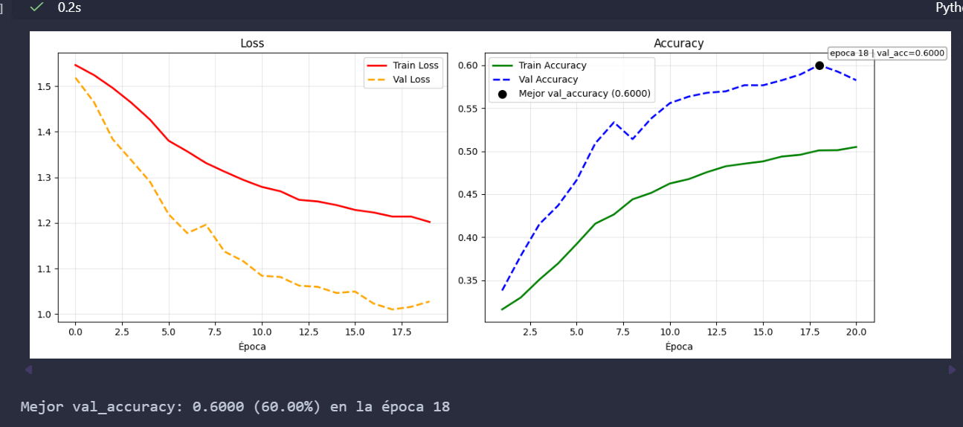

LR=0.001 3x3 32, 64, 128, 256, + DropOut 1densa(100)
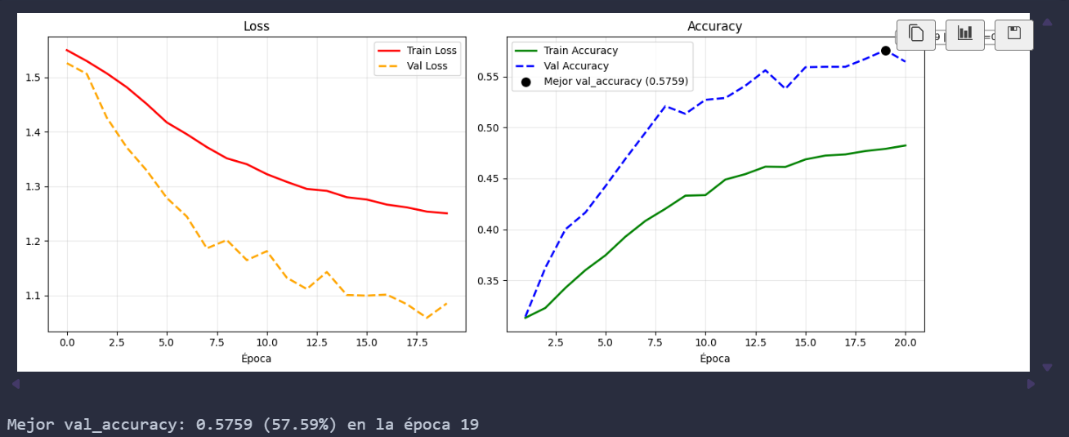

- capas ocultas -> 32, 64, 128, 256 (MaxPool)
- Dropout 0.5
- capas densas -> 100
- lr -> 0.001
- épocas -> 20
- kernel -> 5x5
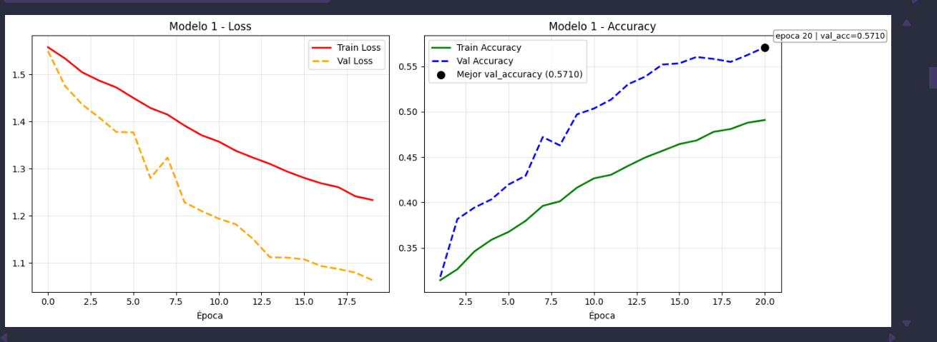

- capas ocultas -> 32, 64, 128 (MaxPool)
- Dropout 0.5
- capas densas -> 128, 64
- lr -> 0.001
- épocas -> 20
- kernel -> 5x5
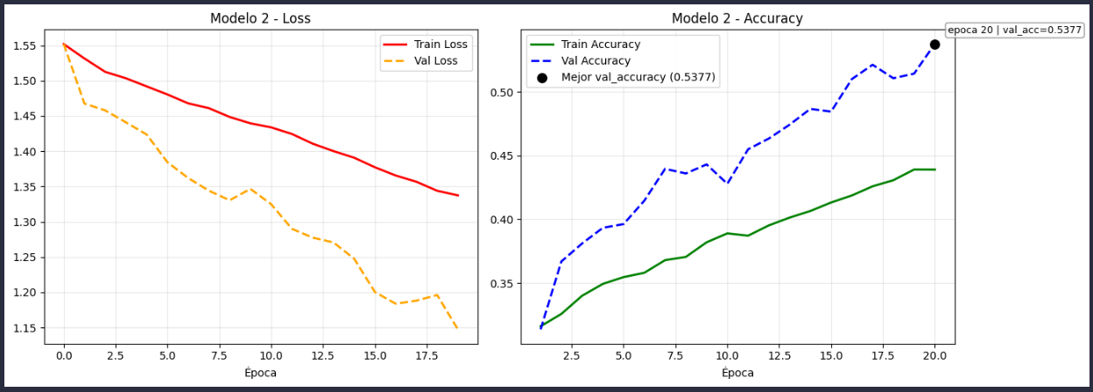

- capas ocultas -> 32, 64, 128 (MaxPool)
- Dropout 0.5
- capas densas -> 128
- lr -> 0.001
- épocas -> 20
- kernel -> 3x3
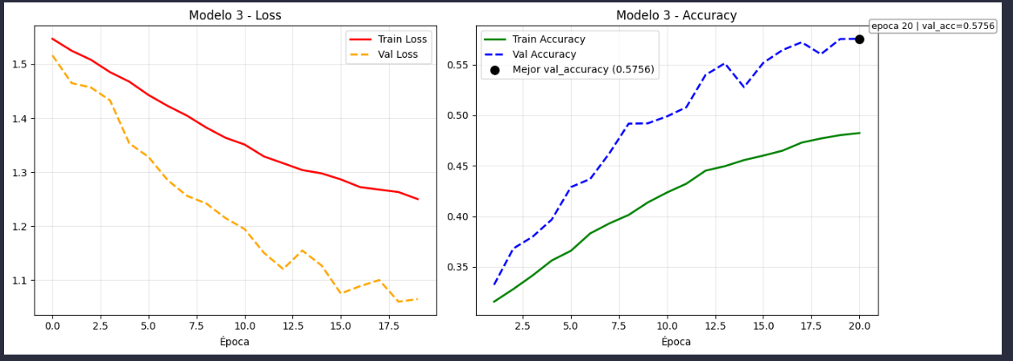

- capas ocultas -> 32, 64, 128, 256 (MaxPool)
- Dropout 0.5
- capas densas -> 128
- lr -> 0.001
- épocas -> 20
- kernel -> 3x3

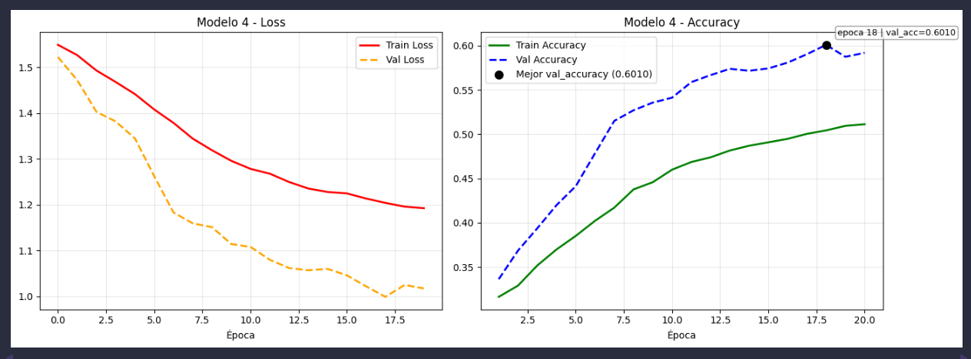

- capas ocultas -> 32, 64, 128 (MaxPool)
- Dropout 0.5
- capas densas -> 128, 64
- lr -> 0.001
- épocas -> 20
- kernel -> 3x3
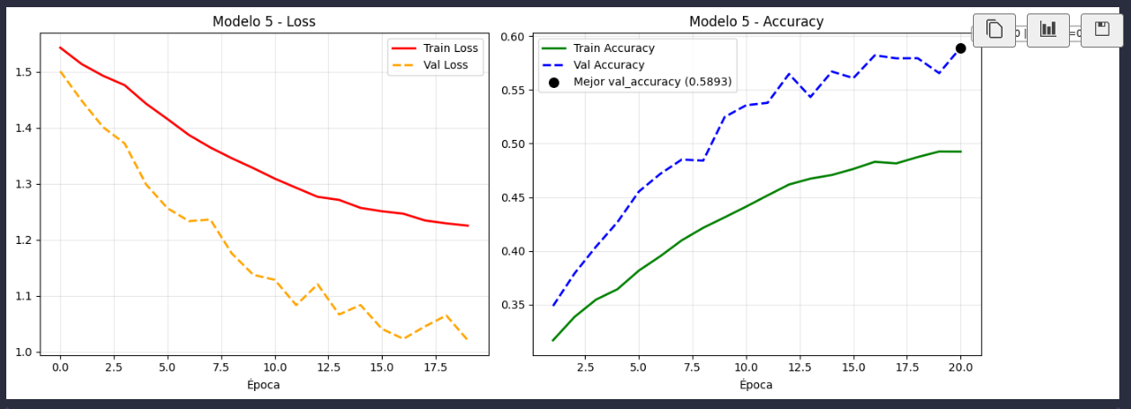

- capas ocultas -> 32, 64, 128, 256 (batch)
- Dropout 0.5
- GlobalAveragePooling2D
- capas densas -> 100
- lr -> 0.001
- épocas -> 20
- kernel -> 5x5
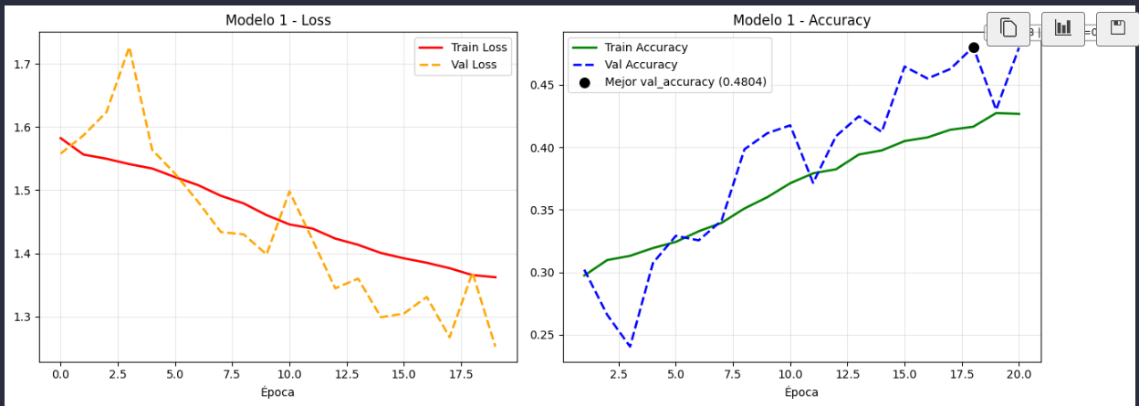

- capas ocultas -> 32, 64, 128 (Bacht)
- Dropout 0.5
- GlobalAveragePooling2D
- capas densas -> 128, 64
- lr -> 0.001
- épocas -> 20
- kernel -> 5x5

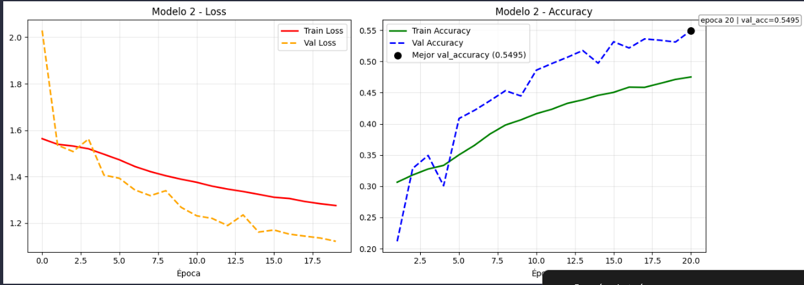

- capas ocultas -> 32, 64, 128 (bacht)
- Dropout 0.5
- GlobalAveragePooling2D
- capas densas -> 128
- lr -> 0.001
- épocas -> 20
- kernel -> 3x3
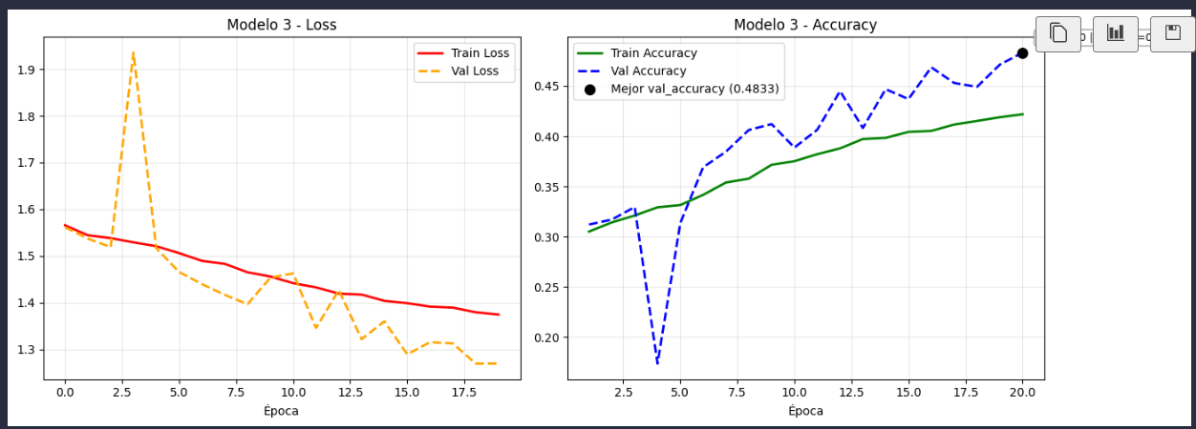

- capas ocultas -> 32, 64, 128, 256 (batch)
- Dropout 0.5
- GlobalAveragePooling2D
- capas densas -> 128
- lr -> 0.001
- épocas -> 20
- kernel -> 3x3
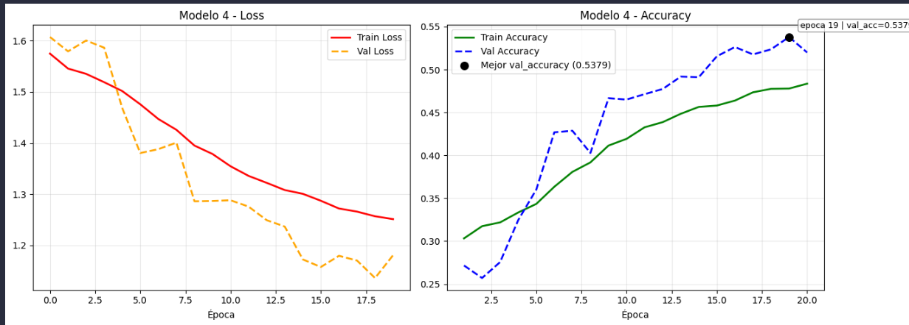

- capas ocultas -> 32, 64, 128 (batch)
- Dropout 0.5
- GlobalAveragePooling2D
- capas densas -> 128, 64
- lr -> 0.001
- épocas -> 20
- kernel -> 3x3
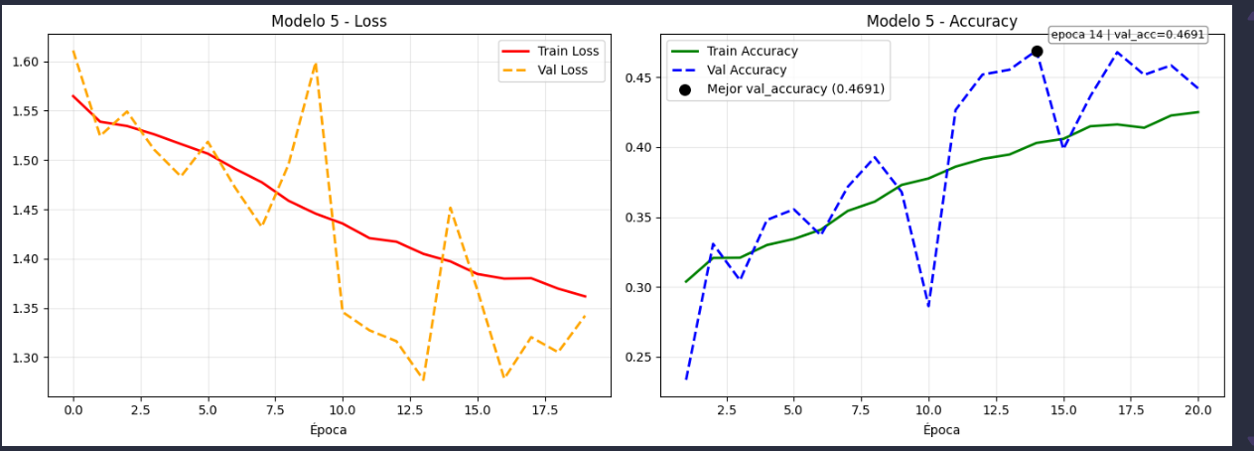

Despues de cambio de augmentacion
- capas ocultas -> 32, 64, 128 MaXPool
- Dropout 0.3
- capas densas -> 256 Flatten
- lr -> 0.001
- épocas -> 20
- kernel -> 3x3

- capas ocultas -> 32+32, 64+64, 128+128 Bath+Maxpool+Drop(0.25)
- Dropout 0.4
- capas densas -> 256 Flatten
- lr -> 0.001
- épocas -> 20
- kernel -> 3x3
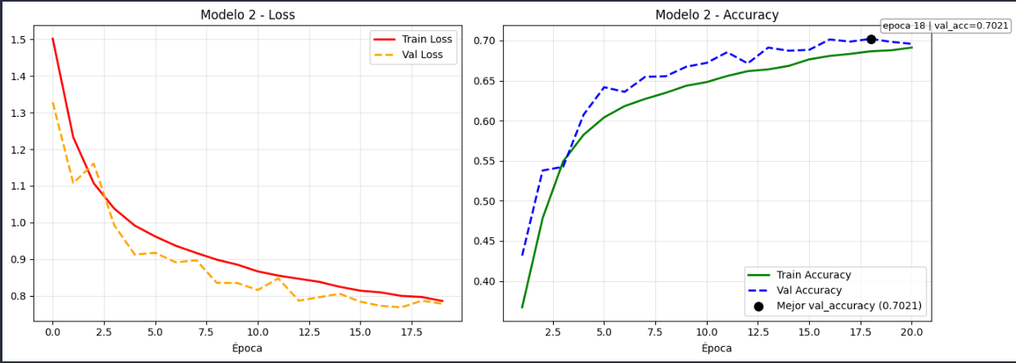

- capas ocultas -> 32, 64, 128 Bath+MaxPool+Drop(0.25)
- Dropout 0.4
- capas densas -> 256 flatten y Regularización L2
- lr -> 0.001
- épocas -> 20
- kernel -> 3x3
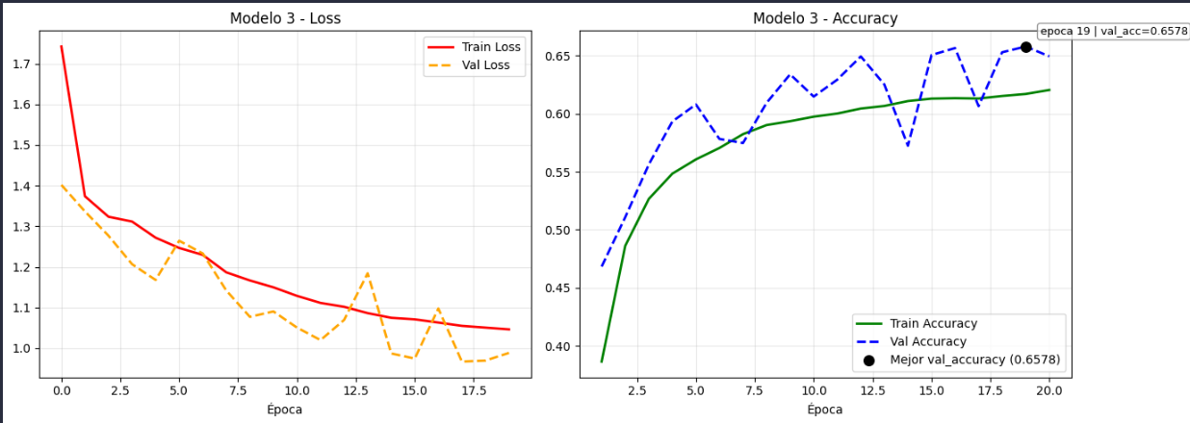

- capas ocultas -> 64, 128, 256 Bacth+MaxPool+Drop(0.25)
- Dropout 0.4
- capas densas -> 256 GlobalAveragePooling2D
- lr -> 0.001
- épocas -> 20
- kernel -> 3x3
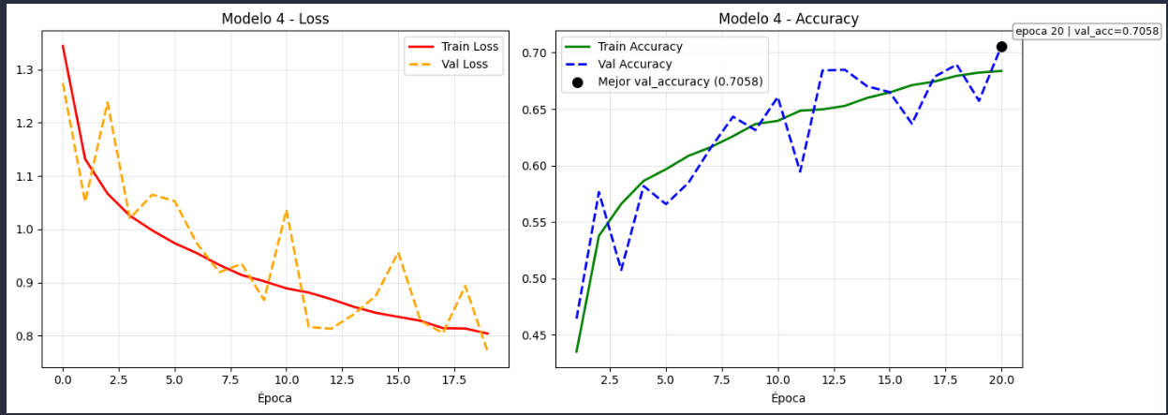

- capas ocultas -> 32, 64, 128, 256 bath+MaxPool
- Dropout 0.4
- capas densas -> 256
- lr -> 0.001
- épocas -> 20
- kernel -> 3x3
